 **LOOPEX**® Natural Efficacy that is Reliable

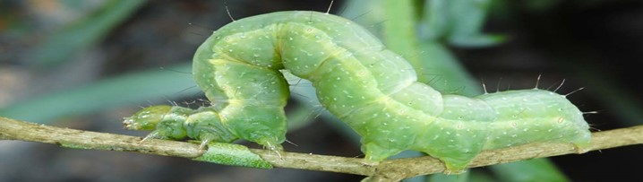



**Technical Information**

**Target Pest Pre-harvest (PHI) and Re-entry Interval (REI)**

*Trichoplusia ni*; common name: Cabbage Looper No residues. PHI and REI are defined according to the national registration regulations

**Crops Toxicity Profile**

Roots & Tuber Vegetables, Leafy Vegetables, Brassica Vegetales Contains no chemical ingredients. No residue

Legume Vegetables, Fruiting Vegetable, Oilseeds, Cucurbit on the crop. Complies with international guide-

Vegetables, Cereal Grains and Speciality Vegetables lines for organic farming. No side effects on mammals, beneficial insects, bees, aquatic

**Formulation** organisms and other non-target organisms. No

Suspension concentrate containing >1.5x1010 OBs (occlusion max- residue levels (MRLs) are defined for

bodies) of *Autographa california* nucleopolyhedrovirus (AcMNPV) Loopex. OMRI Certified for organic inputs

per fluid ounce.

**Standard Dosage Compatability**

Depending upon crop and pressure: 0.7-2.75 fl.oz/ac Compatible with most insecticides, fungicides and fertilizers. **A pH level between 5 and 8.5 in the tank**

**Timing** **mix must be respected.**

For optimal timing, target first application at the beginning of moth

flight, ensuring to continue to cover egg laying and 1st instar presence

**Mode of Action** **Storage**

Larvae need to ingest the virus particles sprayed onto the plant Excellent storage stability:>2 years at -18°C, 2 years

surface in order to become infected. at 5°C, 1 month at 25°C. Avoid temperatures

above 40°C.

**Water Volume Rainfastness**

130-1000 gallons/ac. This should be adjusted according to the Good rain resistance 3 to 4 hours after

canopy density. Repeat applications every 7 days until larvae application.

hatching period is over.



1350 Regent Street

Fredericton, NB Canada E3C 2G6

Phone (506) 444-5690 ● info@andermattcanada.ca

www.andermattcanada.com

**High Selectivity and Safety No Side Effects**

Page 2

The active substance of Loopex® is a *Autographa california* Loopex preserves natural antagonists due toits

nucleoployhedrovirus (AcMNPV). This virus belongs to the specific host range. Aquatic species, birds and

family of Baculoviruses that only occur in arthropod species mammals are not affected. It is also safe for bumble

(mainly lepidopteran species) and generally have a narrow bees, predatory mites, parasitoids, and insects in

host range. Baculoviruses are safe and casue no hazards to general.

human health (OECD, 2002).

**Compatibiity**

**Loopecx® can be used in tank-mixes with other pest-**

**icides, like wettable sulphur, chemical fungicides and**

**insecticides but not with copper products.** A pH level

• Narrow host range, high selectivity, very host specific

• No effects on plants, mammals, or humans

• No production of metabolites or toxins

• Baculoviruses are safe and cause no hazards to human

health (OECD, 2002)

between 5 and 8.5 has to be respected, when tank-

mixed with other products. Otherwise the protective

protein capsule will be destroyed and the active ingred-

ient deactivated. Spraying of copper a few days before

or after a Loopex® application has no adverse effect on

its performance.

**Storage and Handling**

Avoid temperatures above 40°C during storage and transport. Temporarily sub-optimal storage conditions (25-40°C) during transport or by the end-user may be acceptable for a few days. At -18°C the product remains stable and can be immediately used for spraying. Once opened, the package can be stored further at low temperatures without loss of quality.

High temperatures after application are not a limiting factor for the virus efficacy, because temperatures on the plant surface rarely rise above 40°C. At high temperatures the pest activity is also reduced.

Optimal storage conditions are -18°C for >2 years and at 5°C, Loopex® is stable for 2 years, or at for 1 month at 25°C

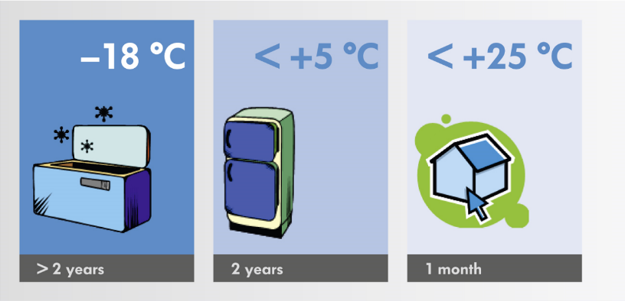

 Page 3



**Mode of Action**

Young larvae that are actively moving and feeding on the crop will ingest the virus that was sprayed onto the plant surface. Following ingestion, the virus particles enter the larval midgut where the protein capsules dissolve due to

the high pH level (pH higher than 10). The virion is released and infects the midgut cells. The genetic information

of the virus is incorporated into the host genome, resulting in the production of new replicate copies of the virus. The

host cells get destroyed and the new viruses infect new host cells. Within 2 – 4 days, the viruses infest most organs of the host and the larva stops feeding. Upon death, the larval body deteriorates and releases millions of new viruses into the environment, infecting other larvae. Under laboratory conditions, only 1 ingested virus particle is sufficient to kill a first instar larva.

Older larvae (older than L3) are not instantly killed and may therefore cause further damage before getting killed in later larval instars. They can also pass on the virus infection to the next generation, where it may develop due to biotic or abiotic stress.

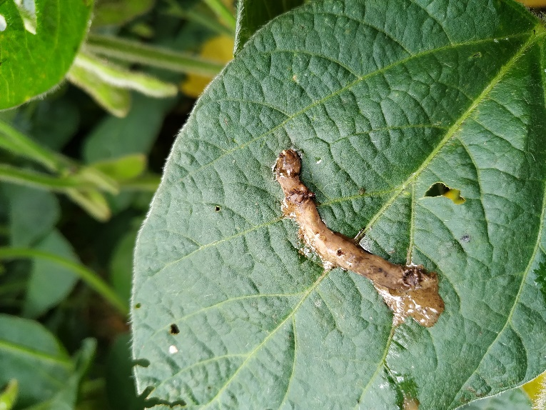

Lepidopteranlarva infected with a baculovirus (NPV) turn dark and then liquify. Eventually decomposing and releasing virus particles to their friends.

Photo Credit: Andermatt do Brazil

Virus replication inside the host and infection of new host cells

Page 4

**Information about *Trichoplusia ni***

Cabbage looper, *Trichoplusia ni*, are an important agricultural pest with an exceptionally broad geographical and host plant range. Cabbage looper can be found worldwide, but are especially prevalent in the warmer regions of all climates. Annual migration occurs to northern regions as temperatures and weather patterns permit. There can be as many as 3 generations in northern climates, and up to 7 generations in the southern climates per year.

Eggs are laid on the underside of leaves. Larvae hatch between 3-6 days and feed on the underside of the leaves. They produce small holes that do not break through the upper surface of the leaves. Older larvae cause the most damage, reducing plant vigor and yield.

**Worldwide Distribution**

**Common Host Crop**

* Brassicas
* Potatoes
* Fruiting Vegetables
* Legumes
* Cucurbits
* Specialty Vegetables

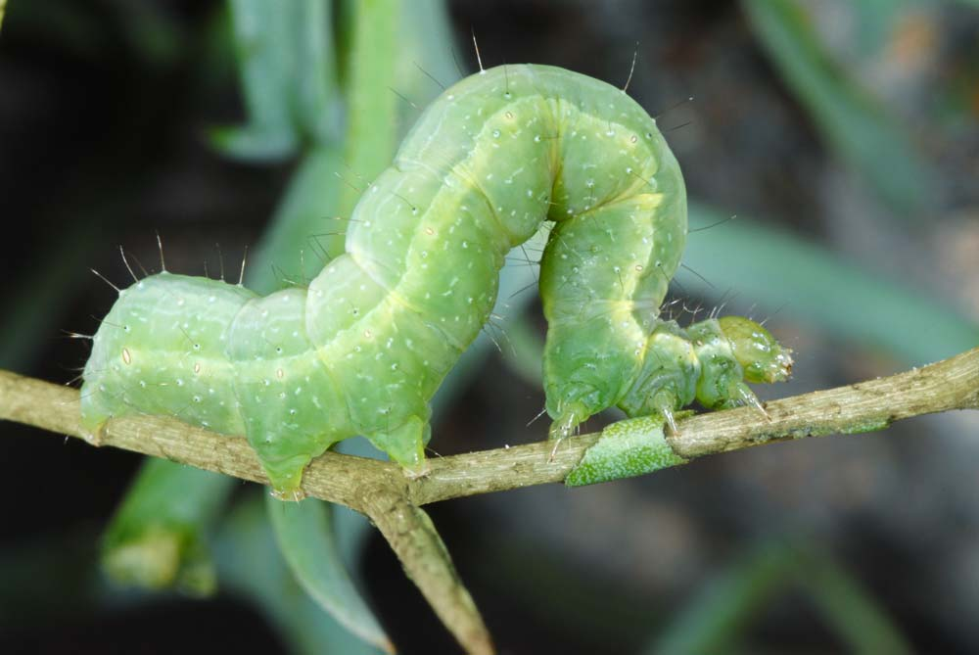

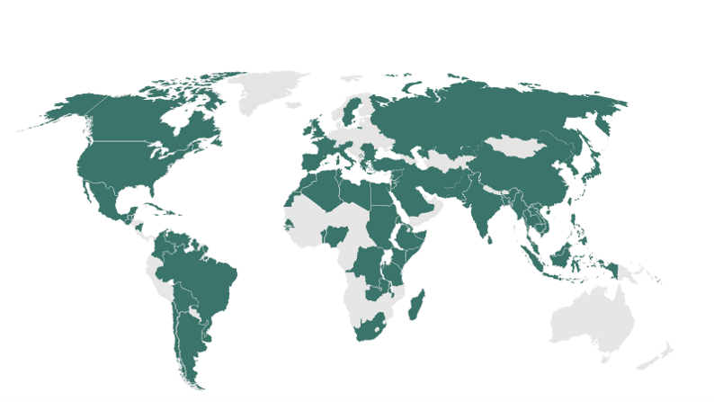

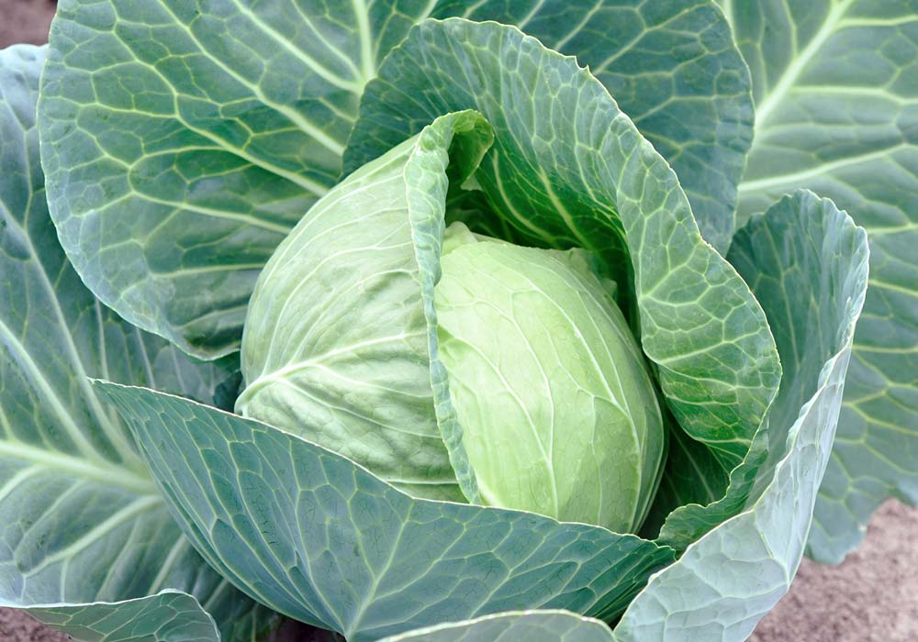



**Life Cycle of *Trichoplusia ni***

Page 5

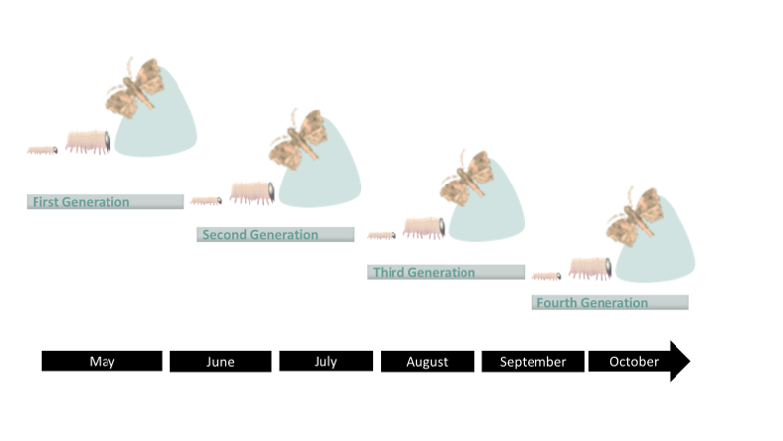

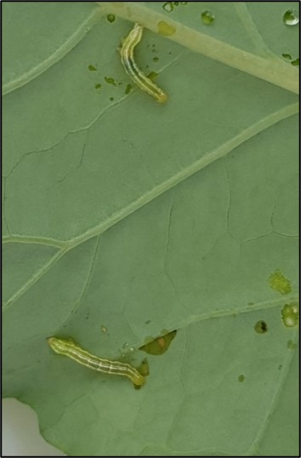

**The cabbage looper can have 3-7 generations in the USA.** Adult female moths will start to lay eggs a few days after eclosion. Each female moth is capable of laying 300-600 eggs which are normally laid over a period of 10-12 days. Egg masses are commonly found on the under side of leaves but under high pest pressure, any surface can be used.

Fecundity of adults and mortality of young larvae is negatively affected by high temperature and low humidity. The life cycle length and number of eggs per female can differ to a great extent, depending on host plant and climatic region. The larvae generally hatch 3-6 days after being laid. The larvae normally pass through six instars and they generally feed for 2-4 weeks.

The increased temperatures in the southern USA can contribute to quick generations resulting in up to 7 generations of cabbage looper during prime growing seasons. Adults have the ability to fly for many miles prior to laying their eggs and therefore have the ability to migrate and expand their populations.

**General Information**

* Up to 7 generations in the USA
* Up to 600 eggs per adult female
* L1-L2 feed on underside of the leaf
* Older Larvae cause the most damage

***T. ni* larvae**: Early instar larvae feeding on broccoli foliage, British Columbia, 2015.

`

**Spray volumes**

Ensuring good leaf coverage improves the efficacy of the application of baculoviruses. Baculoviruses need to be ingested to control larval populations and therefore application equipment should guarantee a good coverage. For ground application, application spray volumes may vary between 130-1000 gallons/acre of water.

For best crop protection, the first Loopex® application is applied just prior to first egg-hatch. The young larvae will consume part of the egg shell during hatching, and therefore can become infected at the earliest possible time point of their development. As baculoviruses are sensitive to UV radiation, spray applications should have an interval of every 6-8 days to assume the full coverage of the larval hatching period. For crops with a high leaf area index, such as cotton, maize and sorghum, application should be repeated after every 8th day with a water volume from 130-1000 gallons/acre.

**Application timing and spray intervals**

**General Instructions**

Weekly monitoring of *Trichoplusia* activity, by using pheromone traps for monitoring the arrival of adults and also scouting for eggs and larvae, is **essential**. Application timing for Loopex° is crucial to provide optimal control over cabbage looper. The first application of Loopex° should target eggs and first instar larvae. Loopex° can provide good efficacy against cabbage looper if applied correctly and at the optimal time to target eggs and small larvae. Good coverage of the feeding area is essential, as the larvae need to ingest the virus to get infected. Young, infected larvae may survive a few days until they die, but feeding activity will be reduced. Older larvae require longer to succumb to the viral infection, and it is therefore essential to apply Loopex° when larvae are still small and not yet hidden within the crop.

Large *Trichoplusia ni* larvae are responsible for creating the most damage within the crops. This highlights the importance of targeting the smaller larvae with Loopex°, prior to their ability to cause economic damage to the crop.

Page 6

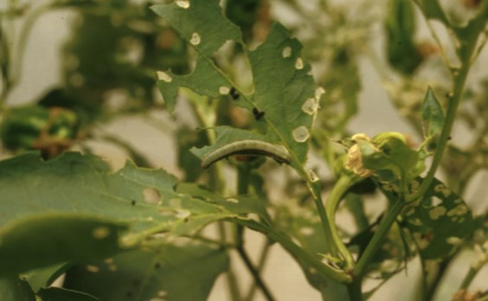

**Lepidopterandamage**: Late instar damage caused by lepidopteran larvae. Targeting small, early instar cabbage looper larvae with Loopex° will reduce this type of damage.

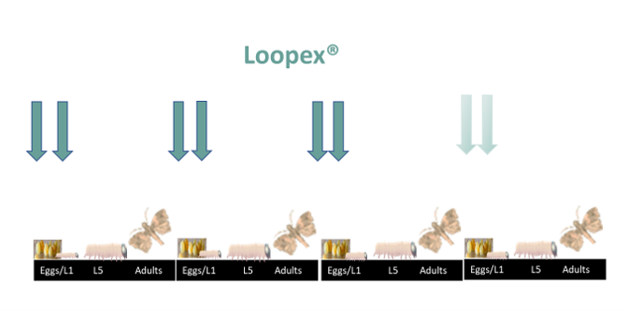

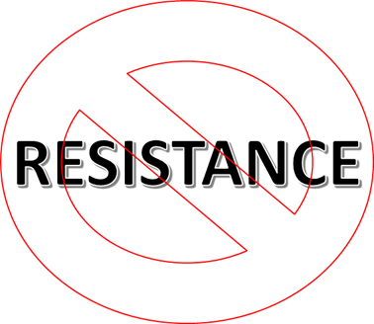

**Application Strategies**

**Use in Integrated Pest Management**

Loopex® can be used as a part of a successful Integrated Pest Management (IPM) program, which may include chemical and cultural practices, aimed at preventing economic pest damage. IPM principles and practices include field screening and monitoring systems (pheromone traps), correct target pest identification, population monitoring, rotation of insecticides with different modes of action and treating when target pest populations reach determined economic thresholds.

**Resistance Management**

*T. ni* has the ability to develop pesticide resistance to numerous control products. To effectively control *T. ni* populations and to delay development to resistant populations to new active substance, a spray program incorporating the most efficacious insecticides and alternating modes of action against consecutive pest generations is recommended. Resistance management in South America is an important factor as *T. ni* can have up to 7 generations per growing season. Alternating modes of action is very important to reduce the potential of resistance development.

Page 7

* Efficient *T. ni* population and damage control
* Excellent Resistance Management tool
* Non-Toxic and safe for beneficial insects (OECD, 2002)
* No Maximum residue level, minimal re-entry period
* Applicable in Integrated Pest Management (IPM) and Organics
* High compatibility with other products
* Good Storage Stability
* Good Rainfastness

**Added Advantages for Loopex®**



**Control of *Trichoplusia ni* on kale, Canada 2015**

Conducted in the western Canada, in the province of British Columbia with kale. Performance of Loopex® at rates from 50-200mls/ha were excellent and better than the standard treatment, *B. thuringiensis kurstaki*.

Page 8

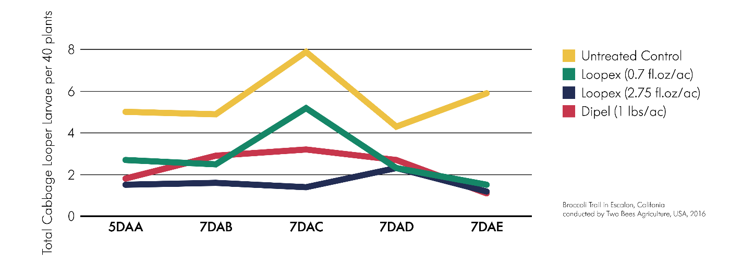

**Loopex® Efficacy Trials**

**Control of *Trichoplusia ni* in broccoli, USA 2016**

Loopex® applied at 0.7 fl.oz/ac and 2.75 fl.oz/ac compared to Dipel (Btk, 1 lbs/ac) and an untreated control

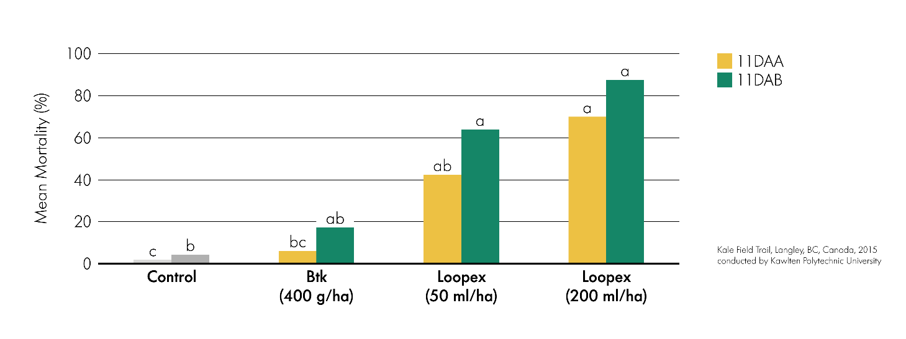



Page 9



**Loopex® - Canadian Made**

Loopex® is produced by Andermatt Canada Inc. in Fredericton, New Brunswick, Canada. Loopex® has been produced since 2012.

Andermatt Canada Inc., is committed to highest quality of it products. Every batched of Loopex® which is produced undergoes a systematic bioassay process. The virulence of each batch is tested against the standard reference batch within the Andermatt Canada laboratories. Only batches which fulfill the high-quality standard criteria will be released into the market.

**Contact**

Andermatt Canada Inc. Phone: +1-506-444-5690

1350 Regent Street Email: info@andermattcanada.ca

Fredericton, NB E3C 2G6

Canada Internet: www.andermattcanada.com

Loopex®

